New Football Field at the PRA
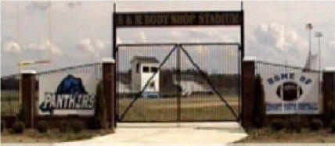
B&R Body Shop, Owner Tommy Morgan, supports our football program with the naming rights to the football stadium for 10 years. We thank Mr. Morgan for his support and dedication to youth football.
The week of June 6, 2005 was a week that brought long days and long nights at the park. Volunteers worked early in the week to set and install the new fence around the football field. Bleacher pads were poured, and the block
work for the press box was laid. Goal posts were painted and set in concrete. On Friday, June 10, 2005 Bermuda Sod for the playing field surface was laid into place. This worked continued all weekend long. On Sunday afternoon the playing surface was in place and the sprinkler system was operational. For those that were able to work this week the park owes you a tremendous thank you. To the block masons that worked until 10:00 Thursday night, we owe you a hand. To Carolina Green, we could not have made this possible without you. To take time away from your busy schedule and bring your crew in from out of town was such a blessing. To all the parents that worked so hard to make this happen we thank you. A special thank you goes to all the wives that put up with their husbands being gone all week. And thank you to the Hispanic crews that worked all weekend long, we could not have completed this without you! You will not be forgotten.
Aerial View:
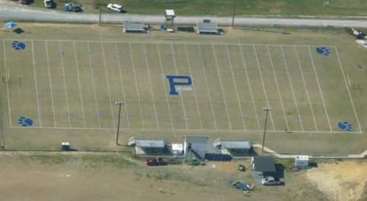
View At Night:
